 | Commonwealth  of Australia | Gazette
No. FSC 115, Thursday, 26 October 2017  Published by Commonwealth of Australia |  | Food Standards

Amendment No. 174
The following instruments are separate instruments in the Federal Register of Legislation and are known collectively in the Food Standards Gazette as Amendment No. 174.

Table of contents

Food Standards (Application A1127 – Processing Aids in Wine) Variation

ISSN 1446-9685
© Commonwealth of Australia 2017

This work is copyright. You may download, display, print and reproduce this material in unaltered form only (retaining this notice) for your personal, non-commercial use or use within your organisation. All other rights are reserved. Requests and inquiries concerning reproduction and rights should be addressed to The Information Officer, Food Standards Australia New Zealand, PO Box 5423, KINGSTON ACT 2604 or by email information@foodstandards.gov.au.

Food Standards (Application A1127 – Processing Aids in Wine) Variation

The Board of Food Standards Australia New Zealand gives notice of the making of this variation under section 92 of the Food Standards Australia New Zealand Act 1991. The variation commences on the date specified in clause 3 of this variation.

Dated: 23 October 2017

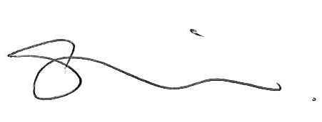
A/g Standards Management Officer
Delegate of the Board of Food Standards Australia New Zealand

Note:

This variation will be published in the Commonwealth of Australia Gazette No. FSC 115 on 26 October 2017. This means that this date is the gazettal date for the purposes of clause 3 of the variation.

1 Name
This instrument is the Food Standards (Application A1127 – Processing Aids in Wine) Variation.
2 Variation to standards in the Australia New Zealand Food Standards Code
The Schedule varies Standards in the Australia New Zealand Food Standards Code.
3 Commencement
The variation commences on the date of gazettal.
Schedule
[[1] Standard 4.5.1 is varied by inserting each of the following into the Table to clause 4, in alphabetical order
Ammonium bisulphite
Chitin-glucan
Polyvinylimidazole-polyvinylpyrrolidone co-polymers
[2] Schedule S18 is varied by inserting each of the following into the table to subsection S18—9(3), in alphabetical order
Ammonium bisulphite | For use in the manufacture of wine, sparkling wine and fortified wine as a microbial nutrient and microbial nutrient adjunct. | GMP
Chitin-glucan | For use in the manufacture of wine, sparkling wine and fortified wine as a decolourant, clarifying, filtration and absorbent agent. | GMP
Polyvinylimidazole-polyvinylpyrrolidone co-polymers | For use in the manufacture of wine, sparkling wine and fortified wine as a decolourant, clarifying, filtration and absorbent agent. | GMP
Silver chloride | For use in the manufacture of wine, sparkling wine and fortified wine to remove fermentation and storage-related odours. | GMP

